**1 INTRODUCTION**

* 1. **Overview**

The ”Creating visually striking certificates for a Debate competition using Canva’’project focuses on creating impressive and memorable certificate to recognize the participants ,winners, and contributors of a debate competition .A well-designed certificate not only serves as a token of achievement but also reinforces the prestige and professionalism of the event.

**1.2 Purpose**

The ‘’Crafting visually striking certificates for a debate competition using canva’’ project focuses on creating impressive and memorable certificates to recognize the participants, winners, and contributors of a debate competition

**2 Problem definition & Design Thinking**

**2.1 Empathy map**

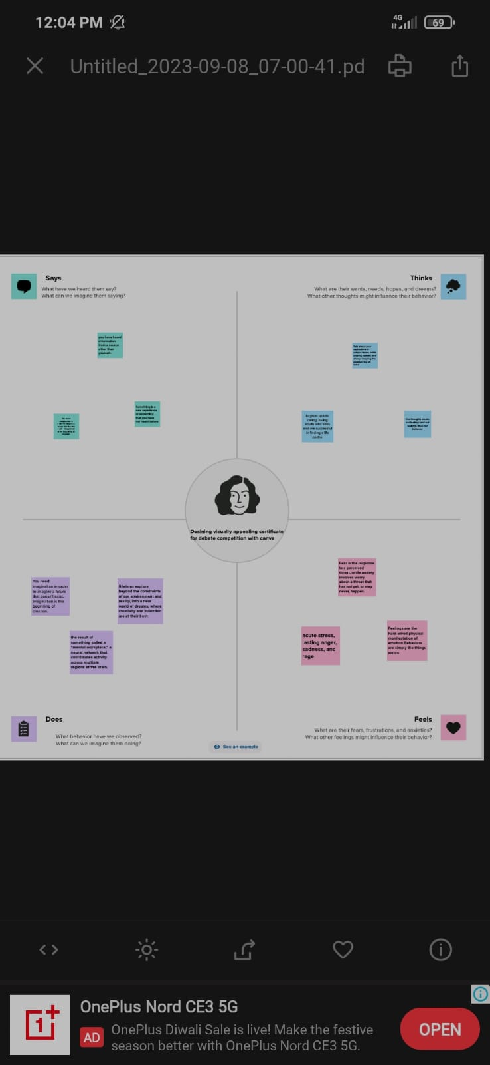

**2.2 ideation & brainstorming map**

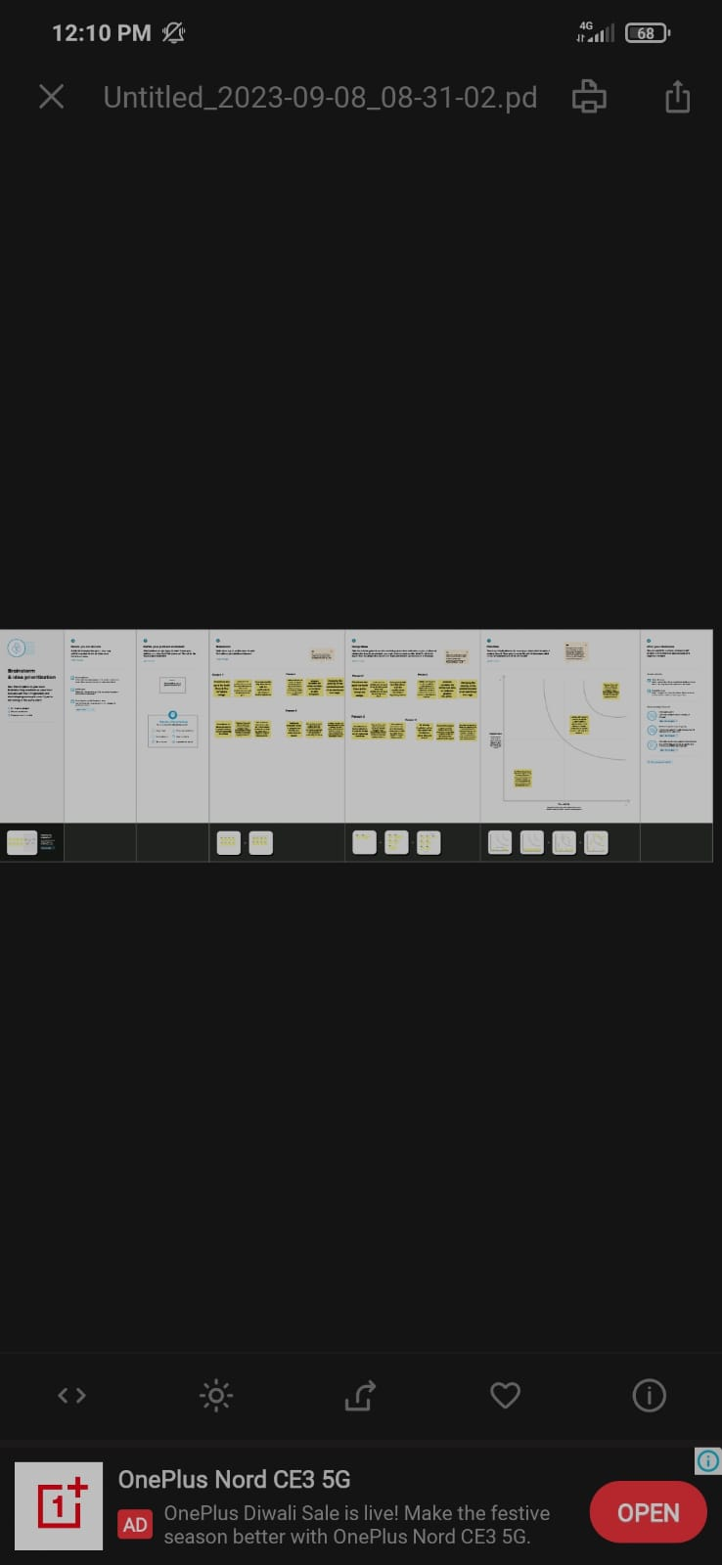

1. **Result**



**4 ADVANTAGES & DISADVANTAGES**

**4.1 Advantages**

**Enhanced Security:** Digital certificates help secure online transactions by encrypting data, thus preventing unauthorized access to sensitive information

**Authentication:** They provide a way to verify the identity of a website, server, or user, ensuring that the entity you are interacting with is genuine

**Trust:** Digital certificates issued by a trusted CA instill confidence in users, as they can be sure that the website or server they are interacting with is legitimate

**4.2 Disadvantages**

**Dependence on Certificate Authorities:** The security of digital certificates relies heavily on the trustworthiness of CAs, which can be compromised or act maliciously

**Complexity:** Managing and deploying digital certificates can be complex, especially for large organizations.

1. **APPLICATION**

**I have used mural application and canva application**

**6 CONCLUSIONS**

**We have created desining certificate with the help of canva**

**7 FUTURE SCOPE**

**We were planning to join the Graphic designing course**